Container Assembly

Untitled Space Craft containers contain module slots for holding modules, utilizing the same magnets that can be found in the modules. These magnets should always have the NORTH side UP in order to properly attract the magnets in the modules.

Wiring

Constructing the cables is a very crucial step with very little room for error. Your ribbon cables should have a red line along it that you can use for orientation. First you should make sure that your ribbon cable is 16 wires rather than 20. If it's 20, then you will need to remove 4 from the non-red side.
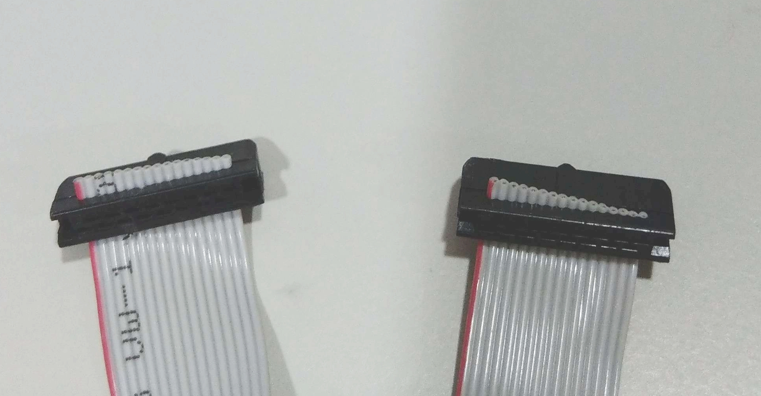

After that you should cut the wire into segments to fit your container. This can be done by counting how many modules removed a particular module is away from the hub. The module that sits on top of the hub is 1. Every module that is adjacent to that module is 2. And every module that is adjacent to a 2 is a 3, and so on. Determining that, you should cut the wires as so:

1: 12cm
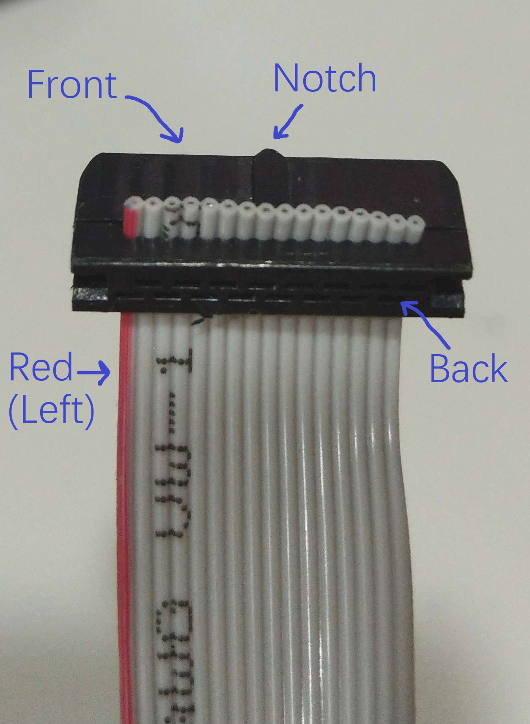
2: 24cm
3: 36cm
4: 48cm

If you hold the wire in front of you with the red line towards the left, then the connector should be facing away from you and with the notch facing up.

Insert the cable into the connector and then press the connector together in the vise, causing it to combine with the cable. Every connector should be added in the same way, with the connectors always facing the same way in relation to the red line. This ensures that the wires can be used in either orientation and interchangeably. If any wires are crossed here, it can be disastrous for your ICs.

